‘On the Barricades’, from War Trilogy (c. 1932), dancers not identified, choreography by New Dance Group collective. New Dance Group Collection, Library of Congress.

*The Haunted Ones* (c. 1942), choreography and performance by Dudley-Maslow-Bales Trio. New Dance Group Collection, Library of Congress, Box 1, folder 3, cropped.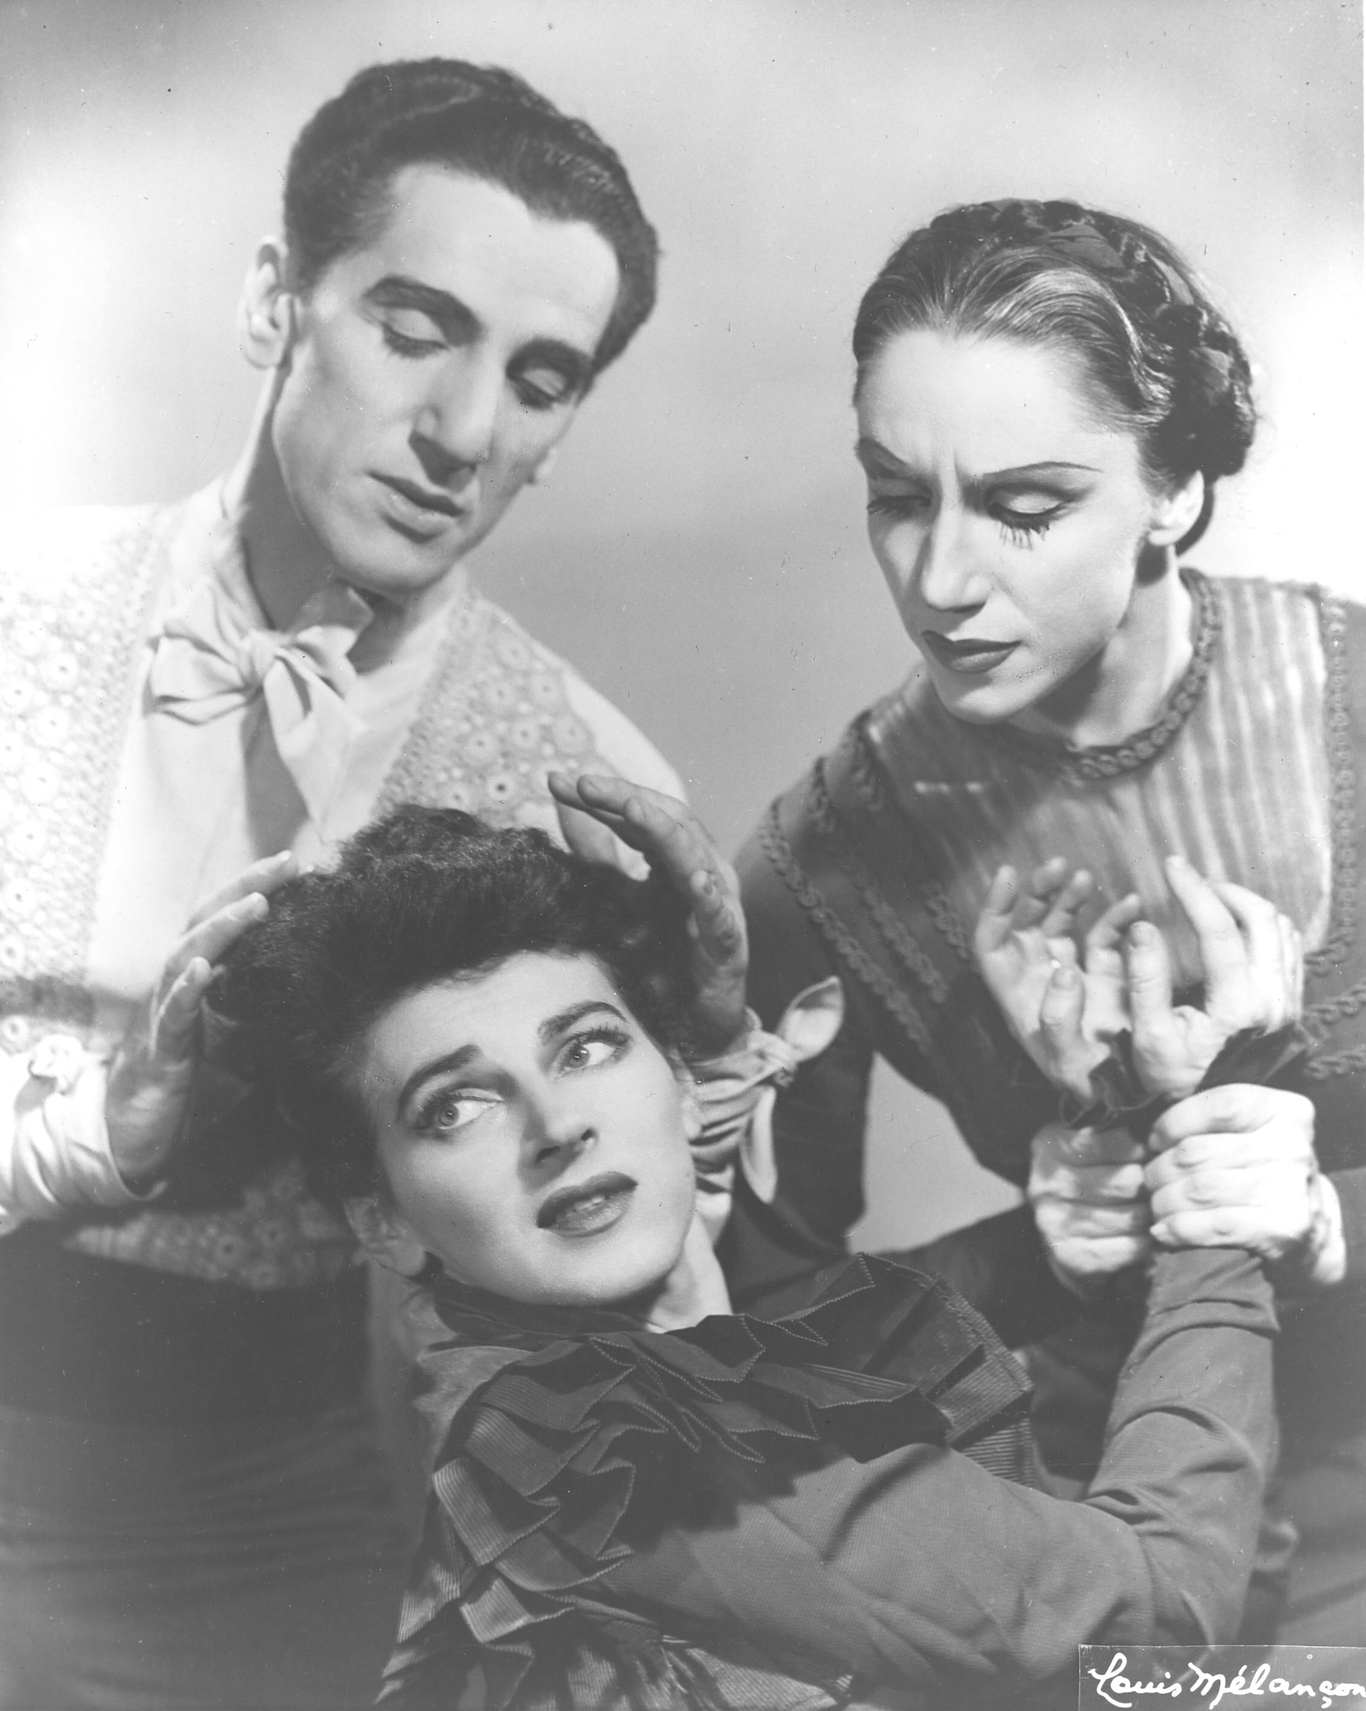

*Games* (1951), choreography by Donald McKayle. Photographer: Philipe Halsman. New Dance Group Collection, Library of Congress, Box 1, folder 28. 